Description of E-visitor’s system architecture
The designed architecture is E-visitor’s system architecture diagram that shows how different biometric and identity verification methods are connected through Robotics hardware and then processed into a digital system.
- Input Methods (Data Capture)
  - Punch card (Igipande) : Put attendance detail on hard paper and stamp time.
  - Scan Hand: Captures a handprint or palm data.
  - Scan Fingerprint: Captures a fingerprint.
  - Scan Card: Reads a card (e.g., National ID, Driving licence, Staff card).
  - Scan Face: Uses facial recognition technology.
  - Scan Voice: Uses voice recognition.
  - Sign pad: use digital sign pen.
  - Invite and confirm: use code or phone number
  - Geste umuntu yakoze akabona kwinjira nikiganza cyawe.
  - Unique id number:
  - Roll call : Click on student or personal image and attend with reason
  - Iris Scanners: Used in high-security environments, this method scans the unique patterns of the iris.
  - Proximity/RFID Cards & Keycards: Users swipe or tap a card with an embedded chip against a sensor to log their attendance. These often double as access control systems for secure areas.
  - GPS Tracking/Geofencing: The app uses the device's location to verify the user is within a specific, predefined geographical area (geofence) when they clock in.
  - QR Codes/Barcodes: A teacher or manager displays a QR code that participants scan with their own devices to mark their presence.
  - Web-Based Systems: Employees log into a website using personal credentials to record their attendance.
  - PIN-based systems: Employees enter a unique personal identification number into a system to log their presence.
- Processing Hardware
  - All these inputs (hand, fingerprint, face, card, voice) are sent to Robotics Hardware, which acts as the main processing hub.
  - This hardware extracts biometric or identity data and prepares it for the software side.
- Data Handling
  - From the Robotics Hardware, the system moves to Get Data and then Send Data to Desktop Application.
  - The Desktop Application processes the data and interacts with a Database (DB) and an API.
  - A Unique Code is generated for each verification or identity process.
- Output
  - Finally, the processed and verified data is made accessible on a Desktop/Web Application, which allows secure access through the internet.
  - Attendance
  - Alcohol test
  - Equipment monitoring
  - Event monitoring
  - Gate pass management
  - Car booking for appointment
  - Blacklisting
  - Team attendance
  - Document and Non-document attendance
  - Excel/ document integration
  - Handover/shift management

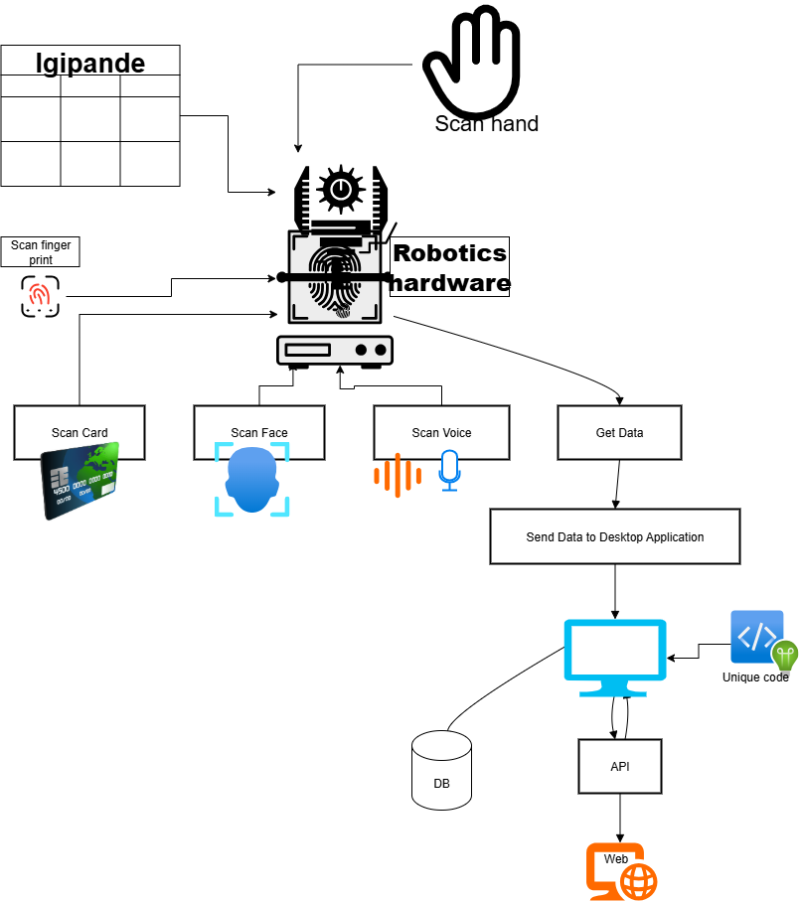

Summary
This diagram represents a biometric and identity verification system that uses multiple authentication methods (hand, fingerprint, card, face, voice). The captured data flows into Robotics Hardware, then into a Desktop Application integrated with a Database and API, and finally delivers verified data through a Web interface.

Use case
